Perplexity AI Web UI/UX Design Insights
Perplexity’s interface is organized around a clean, split layout with a persistent sidebar for global navigation and a main content area for Q&A. For example, a left-hand “Spaces” icon opens a menu of workspaces and templates[1] (see image below). This sidebar isolates global functions (Spaces, Discover/Home, History, etc.) from the main pane, which displays the current thread of question-and-answer exchanges. Each Space shows thread lists (e.g. “My Threads” and “Shared Threads”), and each thread entry offers context menus with actions like moving or sharing the thread[2]. Answers appear in the content pane as discrete cards or bubbles, each with its own citations. A secondary sources panel can be toggled open (via citations or a toggle button) to list numbered references for verification[3]. In short, the UI groups components hierarchically: a fixed sidebar (navigation), a top search/input bar, a central Q&A pane, and a pop-over panel for sources or auxiliary info.
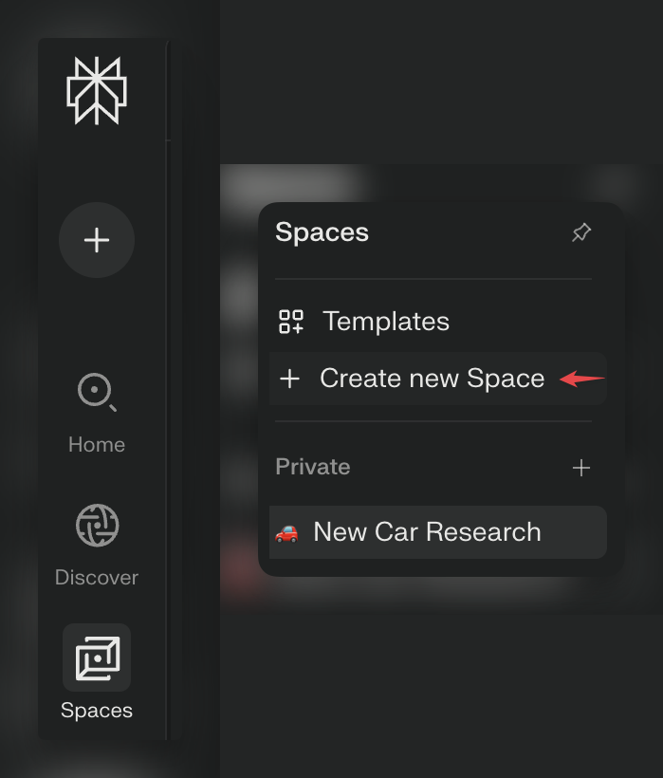
Example: The left-side navigation panel (dark background) holds icons for Spaces, Discover, etc. Clicking “Spaces” opens a small menu (as shown) with options to create or manage Spaces[1]. In this way Perplexity modularizes high-level functions (spaces, history) separately from the main content area.
- Sidebar Navigation: Icons (Spaces, Home/Discover, History) reside in a vertical bar. Clicking them opens panels or lists (e.g. Spaces template menu[1]). This separates workspace controls from answer content.
- Search/Input Bar: The top bar (or prominent search box) includes the query field plus control icons (clear, attach, source selection). This single input serves as both search entry and interactive tool hub.
- Main Content Area: Displays conversation threads of queries and AI answers. Each Q&A block is clearly delineated. Answers include title/text and immediate footnote markers.
- Citations Panel: By default each answer shows numbered citations inline; clicking a citation or a “Sources” toggle opens a sidebar listing each source[3]. This foregrounds evidence alongside answers, reflecting Perplexity’s emphasis on trust via citations[3].
- Modals/Popovers: Interactive overlays (e.g. creating a Space, account settings, command palette) appear as centered dialogs or slide-over panels. Threads and pages support context menus (⋮) for actions, which slide in or fade on demand[2].

Search & Exploration Patterns
Perplexity’s core interaction revolves around natural-language querying. The search bar is always prominent; typing and pressing Enter streams an answer. As you type or focus the input, contextual cues appear (e.g. a blinking cursor or subtle highlight) to indicate readiness. The bar includes tool icons: a “Choose sources” or focus button (often a globe icon) opens a panel of toggles (e.g. Web, Academic, Social, Finance) so users can filter which data sources to use[4]. Similarly, an attach icon lets users drop files into the query[5]. In this way Perplexity enables on-the-fly filtering and input adjustments. After submitting a query, answers may appear progressively (the text often unfolds in real-time), and the interface may briefly show a spinner or skeleton to indicate loading. Each answer card concludes with Related Search links, inviting deeper exploration[6]. These allow users to branch into new queries without starting from scratch, supporting an iterative discovery flow.
- Query Tools: The input row packs utility icons. A paperclip (📎) lets you attach documents for the AI to use[5]. A “Choose sources” globe toggles on/off data channels (web, academic, etc.)[4]. There’s also a clear/X icon to reset context, and often a history/clock icon to revisit past queries.
- Smart Execution: Hitting Enter dispatches the query; the answer typically streams in with a short “generating” animation or placeholder. The text often appears line-by-line or with a subtle typewriter effect, making the AI’s processing visible.
- Follow-up & Suggestions: Under each answer, Perplexity displays related searches or follow-up prompts[6]. These appear as clickable chips or links (e.g. “How do X and Y compare?”), guiding the user deeper without typing anew. This pattern encourages exploration of subtopics.
- Command Palette (hidden): Power users can invoke a quick nav (often via a keyboard shortcut like ⌘K) to jump between sections or features, though this is not visually prominent. It underscores that the UI is optimized for efficient navigation.

Animation & Micro-interactions
Perplexity’s UI uses subtle, functional motion to reinforce actions. While no official animation guidelines are published, the visible behavior shows smooth transitions and feedback. For example, interactive elements like buttons or cards typically highlight or elevate gently on hover, providing instant feedback. Toggle switches slide their knob, and icons (like the FAQ “+”/“-”) rotate or animate when expanding content. The opening of panels (space menus, sources panel) fades or slides into view rather than appearing abruptly. Likewise, expanding a citation list or sharing menu occurs with a brief ease-out transition. These micro-animations use ease-in/out or spring-like timing for a natural feel. The goal is clarity and fluidity – animations are quick but not jarring, making the interface feel responsive.
- Hover Feedback: List items and buttons subtly change (e.g. background tint or slight scaling) on mouse-over. Active elements are highlighted (the UX forum notes “hover effects and active question highlighting” as part of the design language). This confirms interactivity.
- Toggle Animation: Switches in the source panel toggle smoothly (the round slider glides). Accordion-style elements (FAQs or footnote lists) expand/collapse with animated rotation of the “+” icon and a slide motion for content.
- Loading Animations: During network waits, the UI shows animated placeholders (e.g. a pulsing ellipsis or skeleton blocks) in answer areas. When the AI answer arrives, its text appears incrementally rather than dumping all at once, which feels like a live typing.
- Consistency: Transitions and delays are modest (typically a few hundred milliseconds), ensuring quick feedback without feeling sluggish. The design respects reduced-motion settings, disabling non-essential animations when a user’s device requests it (a common modern best practice).

Page Transitions & Loading States
As a single-page app, Perplexity minimizes jarring full-page reloads. Navigating between sections (e.g. opening Settings, switching Spaces) happens dynamically. When a new Space or thread is opened, the existing view smoothly updates; if data is being fetched, the UI often shows a subtle loading overlay or spinner in that panel. The Nicelydone screenshots (many under “Loading state”) suggest they use skeleton loaders or spinners for answer cards and content lists. In general, visible transitions are low-friction: modals fade in, side panels slide out, and nothing snaps out of place. The timing of these transitions is kept brief to maintain flow. This approach keeps the interface feeling continuous and avoids disorienting flashes.
- Loading Indicators: When fetching answers or content, Perplexity typically uses either a subtle spinner or grayed-out content blocks (skeletons) so the layout doesn’t jump. This placeholder disappears once data arrives.
- Seamless Routing: Changing contexts (for example, viewing a different Space or clicking an answer source) updates the view inline. New content slides or fades into place rather than loading a new page.
- Modal/Drawer Transitions: Pop-up panels (e.g. login dialog, share threads) animate into view – often sliding up from bottom or fading in centrally. These use consistent easing so that opening/closing feels coherent across the app.

Interaction Feedback & Implicit Gestures
Perplexity’s design provides clear visual responses to user actions beyond clicks. Hovering over selectable elements highlights them; the currently selected question in a thread is visually distinct (e.g. bold or tinted) to orient the user. Input fields draw a focus outline or shadow when active, signaling readiness for typing. Buttons and icons often change cursor style and use micro-animations to confirm clicks.
- Hover/Active States: Across the UI, hovering triggers subtle changes (background lightening or border glow). For instance, menu items in the Spaces list highlight on hover, and the active tab or question is underlined or colored differently.
- Focus States: When a text input or editable area is focused, it gains a stronger border or ring. This is true for the search field and any form input (e.g. in account settings). The transition into focus is usually immediate, but some fading cue might accompany it.
- Disabled/Empty States: Buttons that are not yet clickable (e.g. “submit” with no query) are dimmed. Empty views (no threads yet) show a friendly placeholder or prompt, avoiding confusion.
- Error/Success Feedback: Form submissions or actions provide quick messages. For example, inviting someone to a Space or failing a search might trigger a toast or inline alert. These typically appear near the top of the pane and fade away or can be dismissed.
Overall, Perplexity’s UI favors clarity and simplicity. The design philosophy – “There are the sources and then there’s an answer”[7] – shows in the stripped-down layout. By modularizing components (side nav vs. content), using progressive reveal of results, and animating only to enhance understanding, the interface feels fluid and purposeful. All animations and interactions follow modern conventions (smooth ease curves, hover highlights, skeleton loaders) so that even without brand-specific styling, the UX patterns would be familiar to any user of contemporary web applications[7][3].
Sources: We analyzed Perplexity’s published UI patterns and design discussions. For example, the Perplexity Help Center confirms the sidebar and source toggles[1][4], while UX commentary emphasizes the simple answer+source structure[7][3]. (No internal design guide was publicly available, so animations are inferred from observed behavior.)

[1] [2] [4] What are Spaces? | Perplexity Help Center
https://www.perplexity.ai/help-center/en/articles/10352961-what-are-spaces
[3] Perplexity Platform Guide: Design for Citation-Forward Answers - Unusual - AI Brand Alignment
https://www.unusual.ai/blog/perplexity-platform-guide-design-for-citation-forward-answers
[5] [6] A Complete How-To Guide to Perplexity AI
https://learnprompting.org/blog/guide-perplexity?srsltid=AfmBOopXoQWfBuNTPxuP5eFdGXdP2oKHLAC7jlLp7qsO7Ijdbp_JzB_q
[7] The UX of AI: Lessons from Perplexity - NN/G
https://www.nngroup.com/articles/perplexity-henry-modisett/

